
SOUTH EAST EDUCATION DIVISION

2026 MALAWI SCHOOL CERTIFICATE OF EDUACTION MOCK EXAMINATION
PHYSICS
PROVISIONAL MARKING SCHEME
PAPER 1(100MARKS)
Section A(70marks)
Question 1
- – properly calibrating measuring instruments before use
- Regular zero checks (any one 1mark)
- Control variable is kept constant throughout the experiment (1), whilst dependent variable is the variable measured as a result of changes in the independent variable (1)
- i. Represents distance/ displacement
ii. acceleration is determined from gradient of the velocity -time graph (1), given as (1)
Question 2
- are quantities which are expressed in terms of other quantities (1)
- true value = measured value – error
(1)
(1)
- from 1963 to 2021= 58 years (1)
since a half- life = 29years, then there are 2 half-lives
(1)
The fraction is ¼ (1)
Question 3
- induced emf is proportional to the rate of change of magnetic flux linkage (1)
- i. 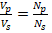 (1)
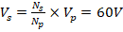 (1)
ii. step-down transformer (1)
iii. - rate of change of magnetic flux
- the strength of magnetic field
- presence of soft iron core
- number of turns in the coil (any one, 1mark)
Question 4
- energy – work theorem states that the net work done by the net force on the rigid body is equal to the change in kinetic energy of the body. (1)
- i. A & C
ii. B
iii. (2marks)
Question 5
- principal axis is a line pass through the two centres of curvatures. (1)
- i. correct scale (1)
correct diagram (1)
position = 6x 20 (1)
=120cm (1)

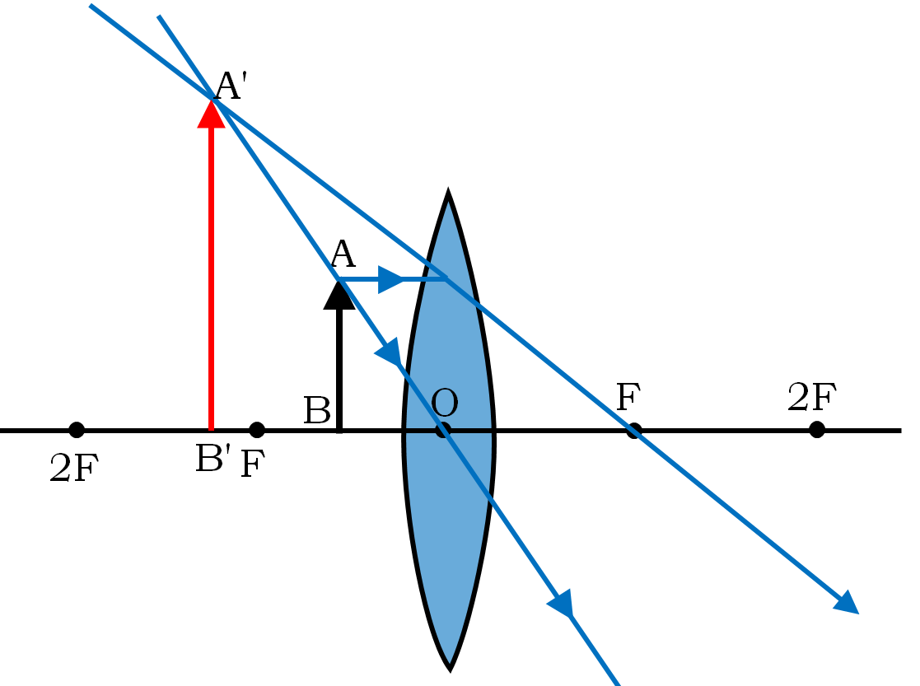
ii. virtual (1), upright (1) and Magnified image (1)
Question 6
- kilowatt-hour is the electrical energy used by 1 kilowatt appliance in 1 hour. (1)
- i. (1)
. (1)
ii. (1)
(1)
- using echo method, (1)
(1)
Therefore, the depth of the lake is 25,000metres (1)
Question 7
- EM waves can travel through vacuum (1)
- i. Transverse wave (1)
ii. (1)
(1)
(1)
(1)
Question 8
- a semiconductor is a material whose electrical conductivity lies between that of good conductors and insulators (1)
- working of seat belts (1) prevent injury due to inertia by pulling back the person when emergency brakes are applied (1)
- i. NOR gate
ii.
Inputs |  | Outputs
A | B | L
0 | 0 | 1
1 | 0 | 0
0 | 1 | 0
1 | 1 | 0

(2marks)
Question 9
- (1)
,
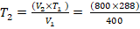 (1)
(1)
- Its Charles law (1) , states that the volume of a fixed mass of gas is directly proportional to its absolute temperature at constant. (1)
- i. 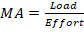 (1)
(1)
ii. (1)
(1)

iii. (1)
(1)
Question 10
- – deep geological burial (1)
- Shielding in lead/concrete containers (1)
- (any other)
- (1)
(1)
(1)
The mass of the body
1kg = 10N (1)
More = 50N
(1)

SECTION B
Question 11
a
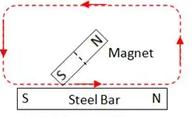(1)
- Place the steel bar to be magnetized on a wooden table. (1)
- Bring one of its poles of strong magnet to one end of the bar as show in figure above. (1)
- Without lifting the magnet, rub it over the bar from one end to the other. (1)
- Upon reaching the other end, lift it well away from the bar and bring it back to the starting end and repeat this several times. (1)
b.
- put one metal in a liquid nitrogen ( (1)
- the metal pipe shrinks (1)
- remove the metal pipe from the liquid nitrogen (1) and insert it into another, positioning it centrally over the joint where both pipe ends meet (1).
- allow the metals to regain their normal temperature, whereby producing a tight fit. (1)

Question 12

- Light from the scene passes through the lens (1). The lens is adjusted (moved slightly forward or backward) to make sure the image is focused sharply.
- The aperture size is set to control the brightness (1). The shutter button is pressed, opening the shutter for a pre-set amount of time (1). This lets a specific amount of light hit the film.
- The film is coated with chemicals called "light-sensitive silver halide emulsion." (1) When light hits these chemicals, it triggers a reaction that creates a "latent" (invisible) image. (1)
- The film is processed in special chemicals to make the image visible and permanent. (1)
- For a body moving in a circular path, angular displacement; (1)
- As the body moves in around the arc, s, the velocity is given by (1)
- Substituting the value of s in the second equation, we get (1)
- But , Hence (1)
Question 13

- Measure a distance of 100m with a tape measure and mark the starting and finishing points. (1)
- Let an athlete stand on the starting point and observer have a stop watch and whistle. (1)
- Let the observer blow the whistle and start the stopwatch immediately. (1)
- Allow an athlete cover the distance three times the observer stops the stop watch.(1)
- Divid the total distance (3x 100m =300m) by the recorded time taken. (1)

- Initially, when the object is dropped, it accelerates (1) under the influence of gravity. As the speed of an object increases (1), fluid resistance also increases (1) and the point is reached where weight of the object is equal to upward force (1). At this point, an object moves at a constant velocity called terminal velocity and there is no further acceleration for the object. (1)

END OF PROVISIONAL MARKING SCHEME!
NB: This paper contains 6 printed pages

